CHAPTER 1
INTRODUCTION

The Music Player is a simple and powerful music player that allows you to enjoy your favourite songs anytime, anywhere. You can easily browse your music library and even play songs directly from the browser. It is built using modern web technologies like HTML, CSS, JavaScript, and Bootstrap for the frontend, and PHP and MySQL for backend functionalities. This application enables users to browse a library of songs, play them and add them to their favourites list. The interface is designed to be responsive, meaning it adjusts to different screen sizes, providing a consistent experience across devices such as desktops, tablets, and smartphones.
The project consists of several key features designed to enhance the user experience, including dynamic rendering of music content, user authentication (login and registration), and the ability to manage favorites through local storage.
The core functionality of the application revolves around allowing users to browse a library of songs, play them in an audio player, and manage their favourite songs list. It is designed with both simplicity and usability in mind, ensuring that users can quickly access and enjoy their music without unnecessary complexity. Additionally, the application features user authentication, allowing users to register and log in to personalize their experience, keeping their favourite songs secure and easily accessible.
Hence, the Music Player Web Application is a dynamic music player that enables users to listen to music, create accounts, and manage playlists. It uses a web-based interface for easy access. The application is designed for simplicity and provides essential features such as user registration, login, song management (adding and deleting songs), and music playback. Built with HTML, CSS, and JavaScript, the music player runs in any modern web browser.
Overall, this Music Player serves as an excellent introduction to web development, showcasing how frontend and backend technologies can be combined to create a fully functional, engaging web-based music player.

CHAPTER 2
AIMS & OBJECTIVES

AIMS

The purpose of this project is to provide a convenient environment to user and to ensure the website is engaging, with features like playing, pausing and adding songs to favorites, offering a simple yet interactive music management system. It designs a simple and easy to-use platform that enables users to stream, manage, and enjoy their music collection without requiring complex software or technical knowledge. It creates a fully responsive web application that can adapt to various screen sizes, making it accessible and functional on both desktop and mobile devices. It allows users to create personal accounts and save their favorite tracks for a customized and enjoyable listening experience.

OBJECTIVES

The objective of this project is to develop a user-friendly interface, to implement responsive design for compatibility with desktops, tablets, and mobile devices and also enables users to mark favorite songs and keep track of recently played music.

CHAPTER 3

SYSTEM REQUIREMENT SPECIFICATION

3.1 HAREWARE REQUIREMENTS
- Operating System: Windows 11
- Processor: 11th Gen Intel(R) Core(TM) i3-1115G4 @ 3.00GHz 3.00 GHz
- System Type: 64-bit operating system, x64-based processor
- Display: Minimum resolution of 1024 x 768 pixels
- RAM: 8.00 GB
- Storage Space: 475 GB
- Input Device: Keyboard and Mouse

3.2 SOFTWARE REQUIREMENTS
- Operating System: Windows 11
- Web Browser: Microsoft Edge, Google Chrome, Internet Explorer, Opera.
- Text Editor / IDE: Visual Studio Code (VS Code) is a powerful code/text editor, perfect for HTML, CSS, JavaScript, or PHP development.
- Web Technologies: HTML5, CSS3, JavaScript, Bootstrap (for responsive design)

CHAPTER 4

DESIGN & IMPLEMENTATION

4.1 SYSTEM ARCHITECTURE
The system architecture consists of three main components:
- Frontend: The frontend consists of HTML, CSS, bootstrap and JavaScript which handles user interactions such as registration, login, song management, and music playback.
- Backend: In this project, localStorage is used as a lightweight backend to store user data and songs. The backend handles saving, retrieving, and deleting data.
- Admin Panel: The admin can manage songs by adding new songs and deleting existing ones.

4.2 TECHNOLOGIES USED
- HTML5: Provides the basic structure of the application and allows the creation of forms, input fields, and buttons.
- CSS3: Used for styling and layout management of the music player application to give it a modern look.
- JavaScript: Adds interactivity and functionality, such as form validation, song addition, deletion, and user authentication.
- Bootstrap: Provides a responsive grid and pre-built styles to enhance the UI of the music player.
- localStorage: Used for storing user and song data on the client-side, enabling persistence across sessions.

CHAPTER 5

RESULTS WITH SCREENSHOTS

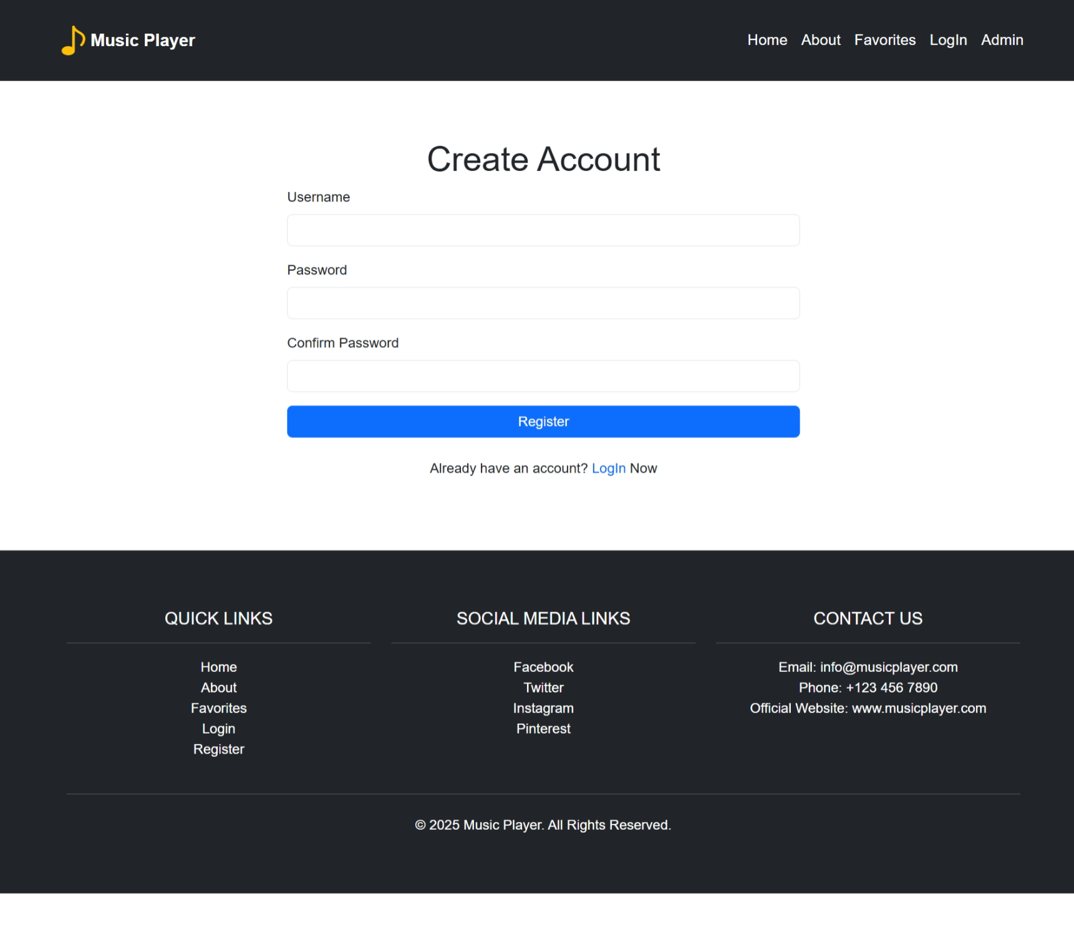
Fig 5.1: Register module

This Figure 5.1 shows the registration module which enables new users to create an account by entering a username, password, and confirming their password. It also provides a link to the login page for users who already have an account.

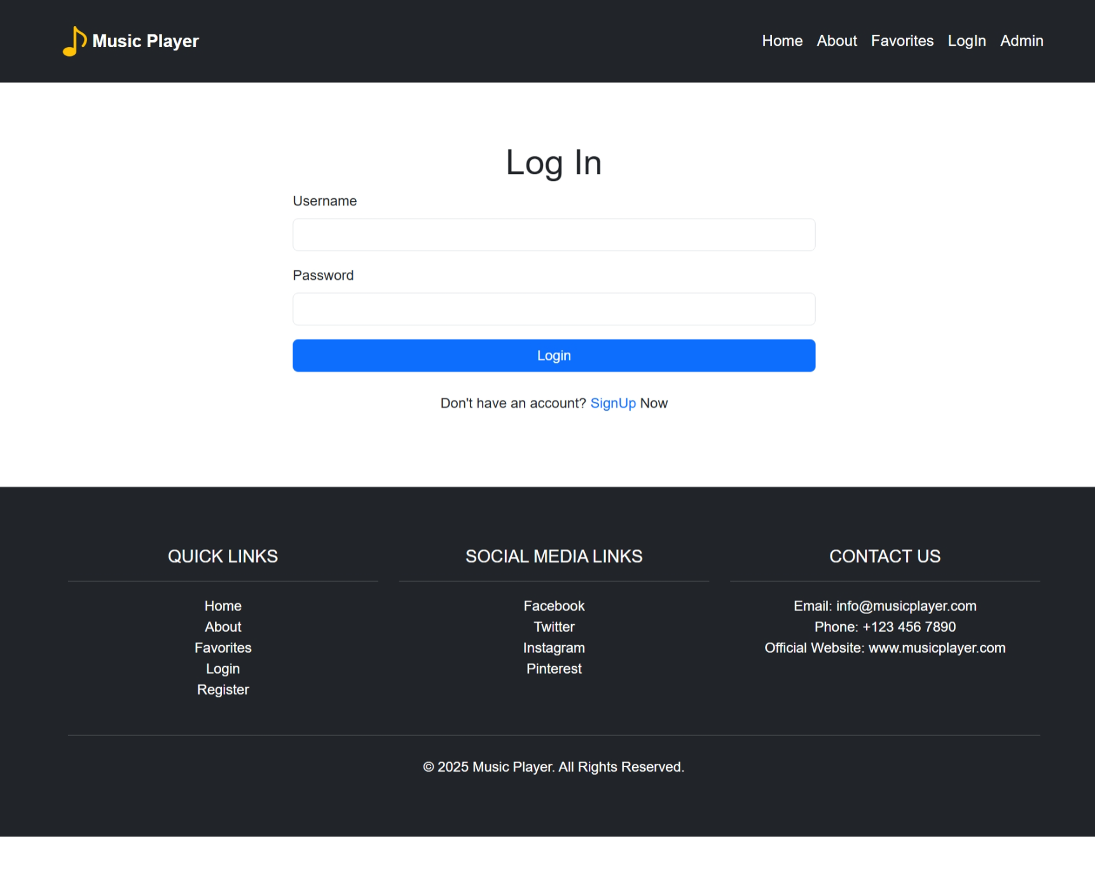
Fig 5.2: Login module

This Figure 5.2 shows the login module which allows users to log in to their existing accounts with a username and password. If users don't have an account, they can navigate to the sign-up page to register.

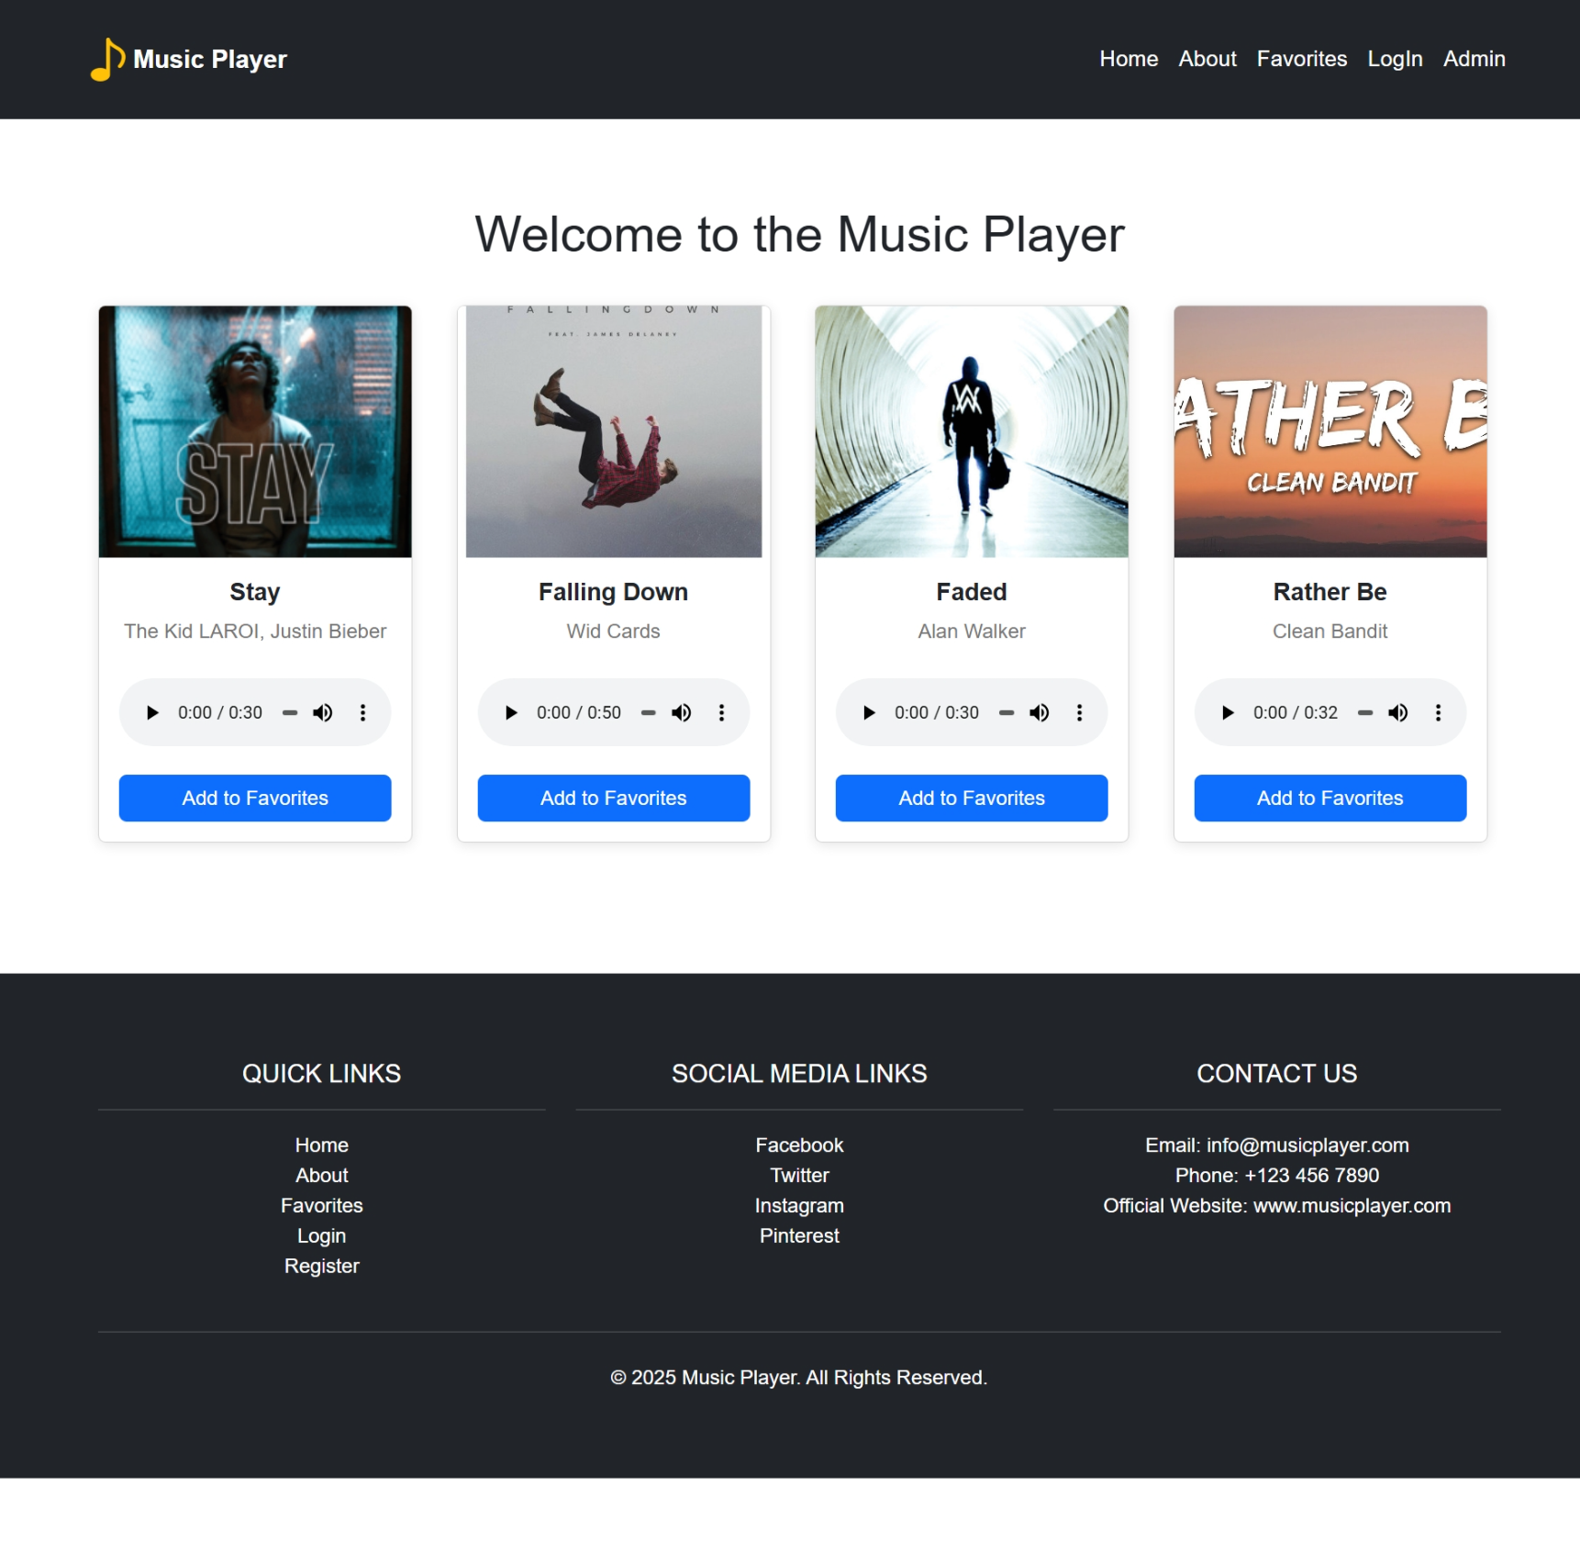
Fig 5.3: Home module

The Figure 5.3 shows the home or index module which is the main landing page where users can view and play available songs, interact with the music library, and explore different features of the music player.

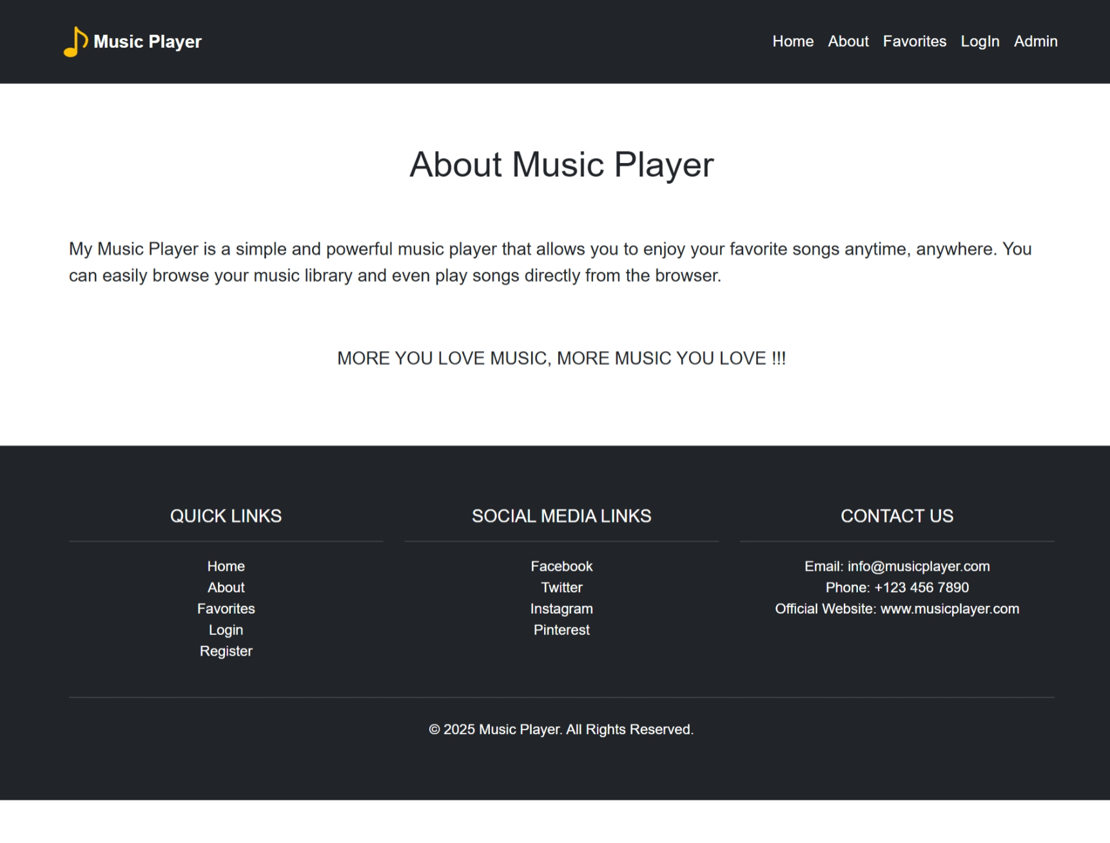
Fig 5.4: About module

The Figure 5.4 shows the about module which provides information about the music player, its features, and the team behind the project. It also includes details on how users can contact support or get involved.

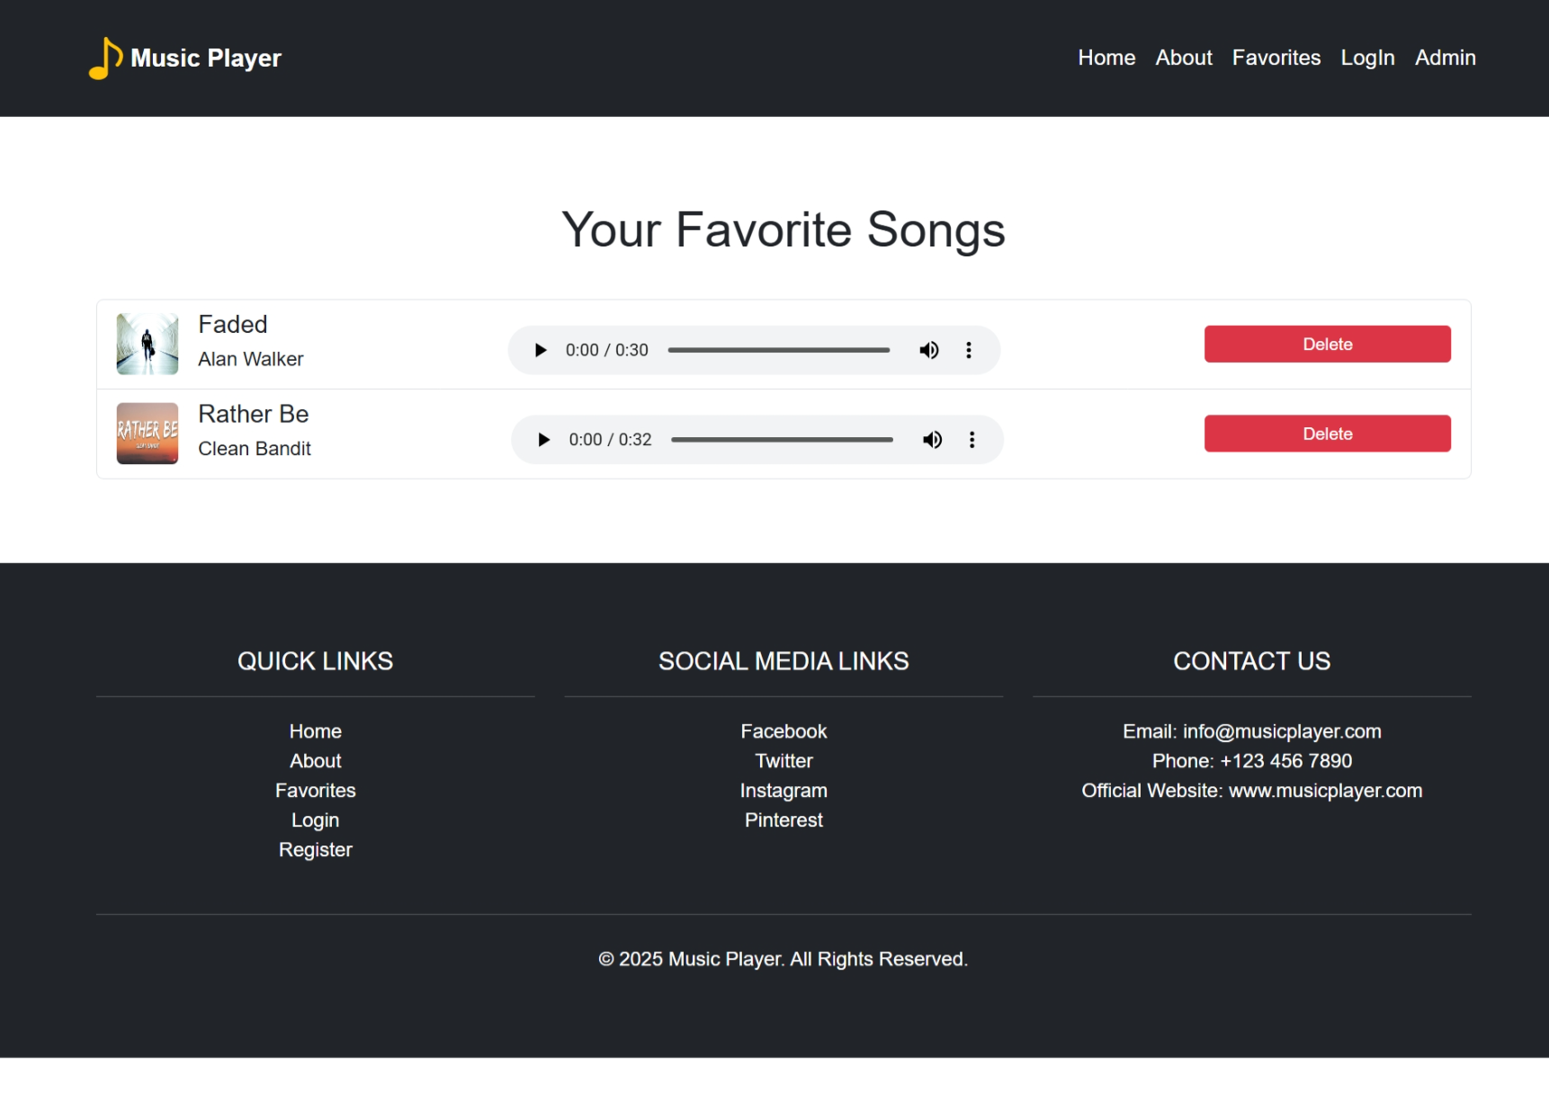
Fig 5.5: Favorites module

The Figure 5.5 shows the favorites module which allows users to view and manage their favorite songs. Users can add songs to their favorites list and easily access them for quick listening.

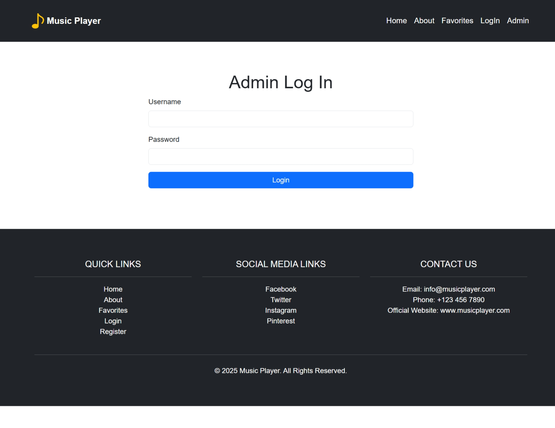
Fig 5.6: Admin login module

The Figure 5.6 shows the admin login module which allows administrators to log in with a username and password. It authenticates the admin before granting access to the admin panel to manage songs and users.

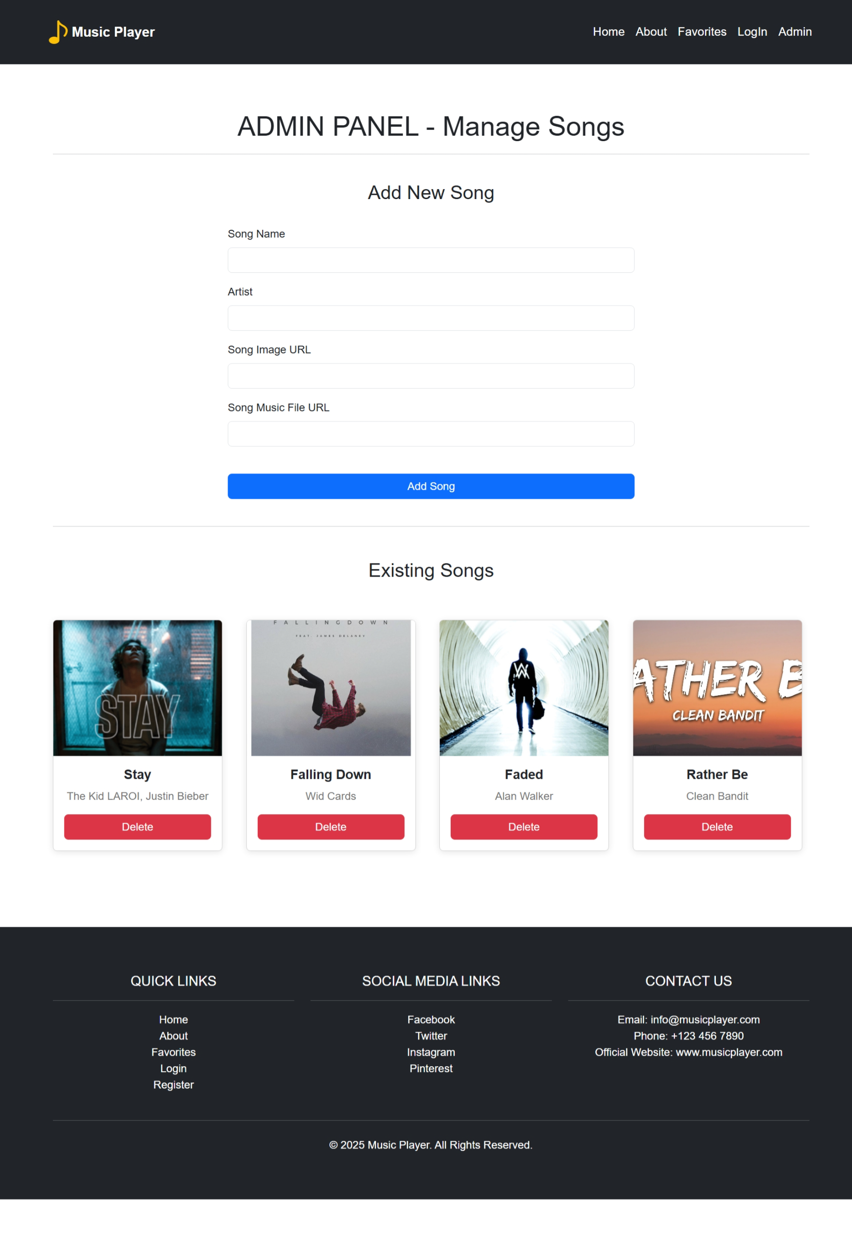
Fig 5.7: Admin module

The Figure 5.7 shows the admin module which serves as the admin panel where administrators can add, view, and delete songs from the music library. It also displays a list of existing songs and allows managing them.
CHAPTER 6

CONCLUSION

The Music Player Web Application project successfully addresses the need for an interactive and user-friendly music player platform, built entirely on web technologies. This project demonstrated the seamless integration of HTML, CSS, JavaScript, and local storage to create a functional, responsive, and easily accessible music player that can be accessed via any modern web browser.
The Music Player Web Application project successfully creates a simple, user-friendly platform for playing music, allowing users to register, log in, and interact with a song library. Built using HTML, CSS, JavaScript, and local storage, the application offers basic features like song playback, user management, and an admin panel for adding or deleting songs.
The use of Bootstrap ensures a responsive design, making the app accessible on various devices. LocalStorage is used to store user data and song information, eliminating the need for a complex backend server. While this approach is lightweight and efficient, it does have limitations in scalability for larger applications.
The project also opens the door to future enhancements, such as the integration of third-party music streaming services (like Spotify or SoundCloud) to access a wider variety of songs, or the development of mobile apps using technologies like React Native or Flutter. Adding more sophisticated security measures such as token-based authentication or integrating OAuth for social media logins would further improve the user experience.
In conclusion, this project is a solid foundation for a fully-fledged music streaming application. While it is a basic version of what could be a more complex system, it has successfully demonstrated the key concepts and technologies required to build an interactive web application. With continued development and the addition of advanced features, this project can evolve into a fully functional and scalable music streaming platform.

CHAPTER 7

FUTURE ENHANCEMENT

While the current implementation of the Music Player Web Application serves its purpose as a basic music player with a simple UI and features, there are several potential areas for improvement and expansion. First, implementing advanced user authentication through technologies like OAuth or integrating third-party services like Google or Facebook login could provide a more secure and scalable login system. This would also help in managing user profiles, preferences, and listening history across multiple devices.
Another significant enhancement would be to incorporate a backend server and a database for storing user data, song information, and preferences more securely. This would enable features such as cloud-based song storage, song ratings, playlists, and user-generated content, making the platform more interactive and personalized. A server-based architecture would also facilitate real-time song recommendations and social features, where users could follow friends, share songs, and create collaborative playlists.
Additionally, integrating streaming protocols such as HTTP Live Streaming (HLS) or WebRTC could improve music playback and allow for streaming from external sources, enabling a more seamless and scalable music experience. Mobile app integration or converting the web app into a progressive web app (PWA) could also increase its reach, allowing users to enjoy music offline or receive notifications about new songs.
Finally, an admin panel could be enhanced to allow for more dynamic content management, including song metadata editing, user moderation tools, and advanced analytics for song and user activity. These features would transform the project into a more robust, modern music streaming platform, offering a richer experience for both users and administrators.

CHAPTER 8

REFERENCES

- https://www.w3schools.com/html/
- https://www.w3schools.com/css/
- https://www.w3schools.com/js/
- https://www.w3schools.com/bootstrap/
- https://getbootstrap.com/
- https://www.w3schools.com/w3css/w3css_templates.asp
- https://www.youtube.com/

